Application Number | 07/2017/3413/REM
Address | Expac (preston) Ltd  Dunkirk Mill  Dunkirk Lane  Moss Side  Leyland  PR26 7SQ
Applicant | MCI Developments Limited, Adactus Housing Group and Neil Kay

Agent
William Fulster
15 Beecham Court
Wigan
WN3 6PR

Development | Reserved Matters application for the erection of 34 affordable dwellings (Appearance, Landscaping, Layout and scale applied for)
Officer Recommendation  Officer Name | That the Members be minded to approve the application and that the decision be delegated to the Planning Manager in consultation with the Chair and Vice-Chair of the Planning Committee upon the successful completion of a Deed of Variation to the Section 106 Agreement on the associated outline planning permission (07/2012/0551/REN) to secure a provision of 100% affordable housing on-site and to amend the tenure to affordable rent accommodation.  Mr Chris Sowerby

Date application valid | 16.11.2017
Target Determination Date | 15.02.2018
Extension of Time | N/A
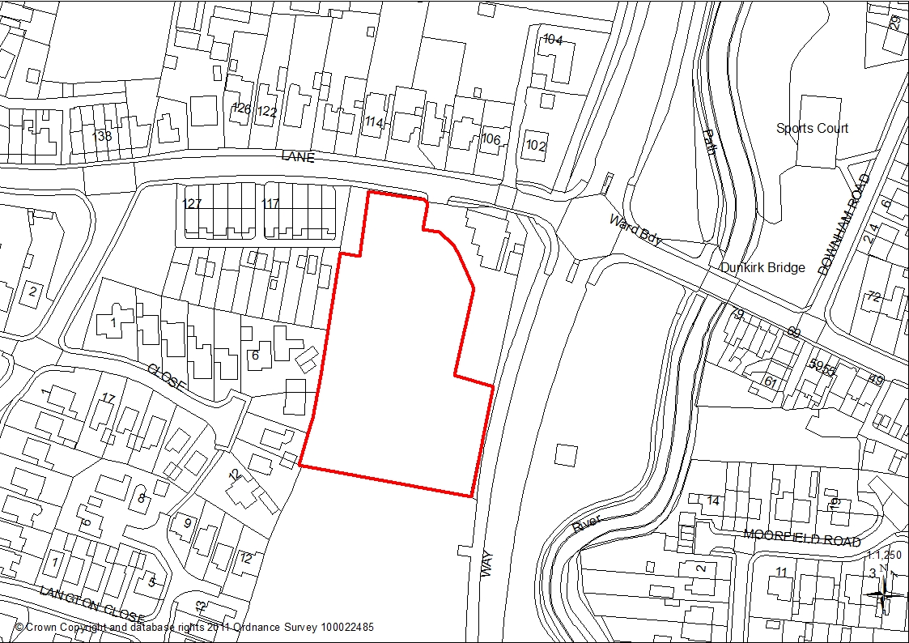

1. REPORT SUMMARY
1.1 The proposal is a Reserved Matters application for the erection of 34 affordable dwellings on the site, with the matters of ‘Appearance’, ‘Landscaping’, ‘Layout’ and ‘Scale’, being applied for. The principle of a residential development on the site, together with the matter of ‘Access’ from Dunkirk Lane, has previously been established by the extant outline planning permission (07/2012/0551/REN).

1.2 The application relates to a 0.67 hectare site formally occupied by Dunkirk Mill. The site is currently vacant and has been largely cleared of built structures, having previously been used for warehousing and distribution purposes by Expac.

1.3 The site is bounded to the north by Dunkirk Lane and beyond by residential properties. To the north-east is the Dunkirk Hall Public House, which is a Grade II Listed Building, together with its associated car park. To the south is a paddock and to the east is Schleswig Way and the River Lostock. To the west are residential detached and semi-detached dwellings on Bretherton Close and a row of terraced houses fronting onto Dunkirk Lane. The site is accessed directly off Dunkirk Lane close to the signalised junction with Schleswig Way.

1.4 The site is allocated as an ‘Allocation of Housing Land’ (‘Site G’) under Policy D1 of the South Ribble Local Plan (2012-2026).

1.5 The proposed mixture of housetypes and designs on the site is not considered to be out of character with the surrounding area. The proposed site layout provides 273sq metres of public open space which exceeds the 120sq metres of public open space on site required through the associated planning consent.

1.6 These proposed inter-relationships are considered to be acceptable and are not considered to result in undue overlooking / loss of privacy or overdominance / overshadowing.

1.7 County Highways have raised no objections to the proposed development.

1.8 The proposed residential development is deemed to be in accordance with Policies 1, 3, 4, 5, 6 and 17 of the Core Strategy and Policies D1, G10 and G17 of the South Ribble Local Plan 2012-2026. For these reasons, and those contained within the report, it is recommended that the application be approved subject to the successful completion of a Deed of Variation to the Section 106 Agreement on the associated outline planning permission to confirm an increase to 100% on-site affordable housing provision and affordable rent tenure of the units.

1.9 The outline permission included conditions relating to highway works, levels, drainage, noise, hours of construction, construction methodology, contaminated land, vehicular linkage and phasing which do not need to be re-imposed as part of the Reserved Matters approval.

2. APPLICATION SITE AND SURROUNDING AREA
2.1 The application relates to a 0.67 hectare site formally occupied by Dunkirk Mill. The site is currently vacant and has been largely cleared of built structures, having previously been used for warehousing and distribution purposes by Expac. The site is located in a largely residential area of Leyland.

2.2 The site is bounded to the north by Dunkirk Lane and beyond by residential properties. To the north-east is the Dunkirk Hall Public House, which is a Grade II Listed Building, together with its associated car park. To the south is a paddock and to the east is Schleswig Way and the River Lostock. To the west are residential detached and semi-detached dwellings on Bretherton Close and a row of terraced houses fronting onto Dunkirk Lane. The site is accessed directly off Dunkirk Lane close to the signalised junction with Schleswig Way.

2.3 The site is allocated as an ‘Allocation of Housing Land’ (‘Site G’) under Policy D1 of the South Ribble Local Plan (2012-2026).

3. SITE HISTORY
3.1 In March 2015 an application for the renewal of outline planning permission (07/2012/0551/REN) was granted for the erection of up to 35 dwellings and the creation of a new access onto Dunkirk Lane (with only the matter of Access applied for) following the completion of a Section 106 Agreement to secure the provision of on-site affordable housing and Public Open Space.

4. PROPOSAL
4.1 The proposal is a Reserved Matters application for the erection of 34 affordable dwellings on the site, with the matters of ‘Appearance’, ‘Landscaping’, ‘Layout’ and ‘Scale’, being applied for.

4.2 The proposal comprises of 4 one-bed Maisonettes, 19 two-bed properties and 11 three-bed properties. A range of semi-detached and terraced housetypes are proposed on the site.

4.3 Three areas of amenity open space are proposed within the development which are to be landscaped to visually improve the development.

4.4 Whilst the associated outline planning consent requires a minimum of 10% intermediate affordable housing units the applicant is working in association with the Adactus Housing Group to provide 100% affordable housing on site in the form of affordable rented accommodation. This is explained further in the ‘Affordable Housing and Variation of S106 Agreement’ section of this report.

4.5 Amended plans have been provided by the applicant in response to comments made by County Highways in relation to the design of the proposed estate road.

5. REPRESENTATIONS
1 letter of objection has been received in relation to the proposed development. A summary of the points raised follows:

Relationship To Neighbours
- Overlooking / loss of privacy
- Overshadowing / overdominance

Other Issues
- Restrictive covenants
- Boundary improvements sought

6. CONSULTATION REPLIES

County Highways identified required improvements to the design of the proposed estate road which have since been incorporated into amended plans. It was also identified that 21 of the proposed dwellings fall short of the recommended individual parking provision, however County Highways have confirmed that they do not raise objection to this under-provision due to the development being wholly for affordable housing and the sustainable location of the site. Even so, the applicant has increased the number of visitor car parking spaces to 5 on amended plans to reduce the potential for on-street parking.

Environmental Health have raised no objections to the proposal subject to the imposition of conditions relating to the control of dust, wheel washing facilities for construction traffic, lighting/noise during construction, hours of construction, control of invasive species, contaminated land, the provision of electric vehicle recharge points and the submission of an acoustic survey. As a number of this are already attached to the associated outline planning consent, only the conditions relating to the provision of electric vehicle recharge points and the submission of an acoustic survey are required to be imposed on any Reserved Matters approval.

An invasive species report has been submitted to the satisfaction of Environmental Health negating the need for a condition to be imposed.

A recommended condition relating restrictions on the burning of waste would be subject to the control of Environmental Health legislation and therefore it is not reasonable to include as a planning condition.

The Local Authority’s Strategic Housing Officer comments that the development of 34 affordable dwellings will support an identified need for affordable rent units and that there are currently 491 applicants on the Council’s housing waiting list (Select Move) that have selected Leyland as their first choice location.

United Utilities have raised no objections to the proposal recommending conditions relating to the submission of foul and surface drainage details and the submission of a sustainable drainage management and maintenance plan.

The Architectural Liaison Officer (Lancashire Constabulary) has raised no objections to the proposal in principle, highlighting a number of potential crime prevention measures which have been forwarded on to the applicant for consideration.

7. MATERIAL CONSIDERATIONS
7.1 The principle of a residential development on the site, together with the matter of ‘Access’ from Dunkirk Lane, has previously been established by the extant outline planning permission (07/2012/0551/REN).

Policy Considerations

7.2 i) NPPF
7.2.1 The NPPF promotes a presumption in favour of sustainable development and supports sustainable economic development to deliver, amongst other things, homes.

7.3 ii) Core Strategy Policy Considerations
7.3.1 Policy 1 of the Core Strategy is entitled ‘Locating Growth’ and encourages the focussing of growth and investment in the Key Service Centres of Chorley and Leyland and the other main urban areas in South Ribble.

7.3.2 Policy 4: Housing Delivery seeks to ensure that sufficient housing land is identified over the 2010-2026 period.

7.3.3 Policy 5 of the Core Strategy covers Housing Density and states:

“The authorities will secure densities of development which are in keeping with local areas and which will have no detrimental impact on the amenity, character, appearance, distinctiveness and environmental quality of an area, consideration will also be given to making efficient use of land.”

7.3.4 Policy 6 of the Core Strategy covers Housing Quality and aims at improving the quality of housing. This is assessed in the following sections of the report.

7.3.5 Policy 7 of the Core Strategy relates to Affordable Housing and confirms a target of 30% affordable housing for housing developments of 15 dwellings or more.

7.3.6 Policy 17: Design of New Buildings expects the design and new buildings to take account of the character and appearance of the local area and effectively mirrors criterion in the South Ribble Local Plan (2012-2026) Policy G17.

7.4 iii) Affordable Housing and Variation of S106 Agreement
7.4.1 Policy 7 of the Core Strategy is entitled Affordable Housing and states that a target of 30% affordable housing provision is to be sought on new housing schemes. The associated outline planning consent agreed a minimum of 10% affordable housing in the form of intermediate units. The applicant is however working in association with the Adactus Housing Group to provide 100% affordable housing on site in the form of affordable rented accommodation. The proposal therefore meets the requirements of Policy 7 but a variation of the S106 Agreement associated with the outline planning consent is required to reflect the change from intermediate affordable housing units to affordable rent units. This change, which reflects situation regarding the provision of affordable housing units and is required in order to secure the necessary grant to fund the development, is fully supported by the Council’s Strategic Housing Officer.

7.5 iv) Open Space
7.5.1 The proposed site layout provides 273sq metres of public open space on site which exceeds the 120sq metres of public open space on site required through the associated planning consent. The three areas of public open space on site are to be landscaped and would be provide a visual amenity for future residents as well as a pleasant entrance to the site from Dunkirk Lane.

7.6 CIL
7.6.1 As the proposed residential development is wholly for affordable housing the development is exempt from the Community Infrastructure Levy.

7.7 Character and Design
7.7.1 Policy 17 of the Core Strategy expects new buildings to “take account of the character and appearance of the local area” with Policy G17 of the South Ribble Local Plan 2012-2026 requiring development not have a detrimental impact on “the existing building, neighbouring buildings or on the street scene by virtue of its design, height, scale, orientation, plot density, massing, proximity, use of materials”. In consideration of the above, the local distinctiveness and character of the local area have been assessed. The surrounding residential development comprises of properties of varying sizes, designs and ages. Consequently, the proposed mixture of housetypes and designs on the site is not considered to be out of character with the surrounding area.

7.7.2 Sufficient garden spaces are proposed for the dwellings. The proposed development is not considered to result the overdevelopment of the site.

7.7.3 For the above reasons the proposed development is considered to comply with Core Strategy Policy 17 and Policy G17 of the South Ribble Local Plan 2012-2026.

7.8 Relationship To Neighbours
7.8.1 A minimum distance of 22m would be present from the front elevation of Plot 1 to the front elevation of 112 Dunkirk Lane. A minimum distance of 21m would be present from the front elevation of Plot 3 to the blank side gable of 109 Dunkirk Lane. A minimum distance of 16m would be present from the blank side gable on Plot 26 to the rear elevation of 10 Bretherton Close. These proposed inter-relationships are considered to be acceptable and are not considered to result in undue overlooking / loss of privacy or overdominance / overshadowing.

7.8.2 Minimum distances of 9m and 13m respectively would be present from the rear elevations of 8 and 9 Bretherton Close to the front elevation on Plot 27. Whilst these distances fall short of the minimum standard separation distances that the Council normally applies, in this case the relationship with the Plot 27 is not direct and the acuteness of this angled relationship is considered sufficient to prevent the proposed development from having an undue overlooking / loss of privacy or overdominance / overshadowing. Historically, the rear elevations of 8 and 9 Bretherton Close used to directly face a single storey building used for packaging uptight against the party boundary. The proposed layout, with no built development directly opposing the rear elevations of 8 and 9 Bretherton Close will not result in the overshadowing / overdominance historically experienced in their rear gardens.

7.9 Highway Issues
7.9.1 The access on to Dunkirk Lane to serve the residential development has been established as part of the associated outline planning consent.

7.9.2 Amendments have been made to the internal site layout following recommendation made by County Highways. Consequently the proposed internal layout has now been designed to adoptable standards.

7.9.3 Whilst it has been identified by County Highways that 21 of the proposed dwellings fall short of the recommended individual parking provision, no objections have been raised by County Highways to this under-provision due to the development being wholly for affordable housing and the sustainable location of the site. The applicant has also decided to increase the number of visitor car parking spaces to 5 on amended plans to reduce the potential for on-street parking.

7.10 Tree Issues / Wildlife
7.10.1 The site is formed entirely of hardstanding and is devoid of trees or vegetation. A row of trees is present along the eastern boundary of the site close to Schleswig Way however no built development is proposed in this section of the site due to a an existing drain easement being present.

7.10.2 An ecology report submitted with the associated outline consents included recommendations for measure to maximise opportunities for wildlife on the site. In response to this the applicant is proposing to landscape the on-site areas of public open space in line with the recommendations of the ecology report. There is no evidence of any protected species within the vicinity of the site.

7.11 Impact on Listed Building
7.11.1 Beyond the eastern boundary of the application site is the car park and servicing area associated with the Dunkirk Hall public house (a Grade II Listed Building). The proposed development, which makes good use of a vacant and visually unattractive site, would preserve the character and appearance of the Listed Building.

7.12 Other Issues
7.12.1 A neighbour has highlighted the potential for boundary improvements where the site abuts existing residential development. The application proposes the installation of a 1.8m high feathered edge timber fence along party boundaries with existing residential development. Such boundary treatments are common place where new residential developments abut existing residential properties and there is not considered to be any site specific circumstances to reasonably request for the proposed boundary treatments to be upgraded.

7.12.2 A neighbour has raised issues surrounding the potential implications of restrictive covenants. Any such covenants are not subject to the control of Planning and would be a private legal matter between the involved parties.

8. CONCLUSION
8.1 The proposed residential development comprising of 34 affordable dwellings is considered to be acceptable on the 0.67 hectare site. The proposed development is not considered to result in the overdevelopment of the site and is not considered to be out of character with the streetscene. The proposed development is not considered to have an undue impact on the amenities of neighbouring properties or an adjacent Listed Building and there are no significant highway safety or amenity implications.

8.2 The outline permission included conditions relating to highway works, levels, drainage, noise, hours of construction, construction methodology, contaminated land, vehicular linkage and phasing which do not need to be re-imposed as part of the Reserved Matters approval.

8.3 The proposed residential development is deemed to be in accordance with Policies 1, 3, 4, 5, 6 and 17 of the Core Strategy and Policies D1, G10 and G17 of the South Ribble Local Plan 2012-2026. For these reasons, and those contained within the report, it is recommended that the application be approved subject to the successful completion of a Deed of Variation to the Section 106 Agreement on the associated outline planning permission to confirm an increase to 100% on-site affordable housing provision and affordable rent tenure of the units.

9. RECOMMENDATION:

That the Members be minded to approve the application and that the decision be delegated to the Planning Manager in consultation with the Chair and Vice-Chair of the Planning Committee upon the successful completion of a Deed of Variation to the Section 106 Agreement on the associated outline planning permission (07/2012/0551/REN) to secure a provision of 100% affordable housing on-site and to amend the tenure to affordable rent accommodation.

RECOMMENDED CONDITIONS:

1. The development hereby approved shall be begun either before the expiration of 3 years from the date of the outline permission, or before the expiration of 2 years from the date of the permission herein.

REASON: To comply with the requirements of Section 92 of the Town and Country Planning Act 1990

2. The development shall be carried out in accordance with the approved materials schedule detailed on the approved Drawing ref. 'Dunkirk Lane / Materials Distribution Rev. C' unless otherwise agreed in writing with the Local Planning Authority.

REASON: To ensure the satisfactory detailed appearance of the development in accordance with Policy 17 in the Central Lancashire Core Strategy and Policy G17 in the South Ribble Local Plan 2012-2026.

3. No property shall be occupied, or be brought into use, until their respective car parking spaces have been surfaced or paved in accordance with a scheme to be approved in writing by the Local Planning Authority and the car parking spaces and manoeuvring areas marked out in accordance with the approved plan.

REASON: To allow for the effective use of the parking areas, in accordance with Policy 17 in the Central Lancashire Core Strategy and Policy F1 of the South Ribble Local Plan 2012-2026.

4. Prior to the occupation of each phase of development, a scheme and programme for the laying out, landscaping, maintenance and retention of any area of public amenity land within that phase, shall be submitted to the Local Planning Authority for approval in writing. The development shall proceed in accordance with the agreed scheme within a timeframe to be agreed in writing with the Local Planning Authority.

REASON: In the interests of visual amenity of the area in accordance with Policy 17 of the Core Strategy and Policy G17 of the South Ribble Local Plan 2012-2026.

5. The approved landscaping scheme, as detailed on Drawing no. '5090.01 Rev A' shall be implemented in the first planting season following completion of the development or first occupation/use, whichever is the soonest, and shall be maintained thereafter for a period of not less than 5 years to the satisfaction of the Local Planning Authority, in compliance with BS 5837 2012 - Trees in Relation to Design, Demolition and Construction - Recommendations. This maintenance shall include the watering, weeding, mulching and adjustment and removal of stakes and support systems, and shall include the replacement of any tree or shrub which is removed, becomes seriously damaged, seriously diseased or dies by the same species. The replacement tree or shrub must be of similar size to that originally planted.

REASON: In the interests of the amenity of the area in accordance with Policy 17 in the Central Lancashire Core Strategy, Policy G13 and Policy G17 in the South Ribble Local Plan 2012-2026

6. Prior to the commencement of any works on site an assessment for the presence of invasive plants, as identified under the Wildlife and Countryside Act 1981, shall be undertaken and the results submitted to the local planning authority for approval along with a detailed methodology for the removal of any identified invasive plants.

REASON: The spread of invasive plants is prohibited under the Wildlife and Countryside Act 1981. Without measures to prevent spread as a result of the development there would be the risk of an offence being committed and avoidable harm to the environment recurs

7. Prior to the commencement of the construction of Plot 1-18 an acoustic survey shall be undertaken covering the impact of road traffic noise and noise from the public house, Dunkirk Hall, upon those plots. Details of the findings of the survey and any mitigation measures identified shall be submitted for approval to the local planning authority. Once approved the mitigation measures shall be carried out as approved prior to the first occupation of each plot or as agreed otherwise with the local planning authority. The approved mitigation measures shall be retained and maintained thereafter.

Reason: In the interests of the amenity of the nearby residents in accordance with Policy 17 of the Central Lancashire Core Strategy and NPPF.

8. An electric recharge point shall be provided to each property, as detailed on the submitted drawing ref 'Dunkirk Lane / Car Charging Plan', prior to occupation. A switch shall be provided internally to allow the power to be turned off by the residents.

Reason: To enable and encourage the use of alternative fuel use for transport purposes in accordance with Policy 3 of the Central Lancashire Core Strategy.

9. The development, hereby permitted, shall be carried out in accordance with the submitted approved plans Dwgs no. 'Dunkirk Lane / Site Location Plan', 'Dunkirk Lane / 3B5P Aspect House Type', 'Dunkirk Lane / 3B5P House Type', 'Dunkirk Lane / 3B4P Aspect House Type', 'Dunkirk Lane / 2B4P House Type', 'Dunkirk Lane / 2B4P House Type', 'Dunkirk Lane / 1B2P Mais', 'Dunkirk Lane / Open Space Plan A', 'Dunkirk Lane / Boundary Treatments D', 'Dunkirk Lane / Proposed Site Layout J' and 5090.01 A (Landscape Proposal).

REASON: To ensure a satisfactory standard of development in accordance with Policy 17 in the Central Lancashire Core Strategy and Policy G17 in the South Ribble Local Plan 2012-2026.

RELEVANT POLICY

1 Locating Growth (Core Strategy Policy)

3 Travel (Core Strategy Policy)

4 Housing Delivery (Core Strategy Policy)

5 Housing Density (Core Strategy Policy)

6 Housing Quality (Core Strategy Policy)

17 Design of New Buildings (Core Strategy Policy)

POLD1 Allocations of housing land

POLG10 Green Infrastructure Provision in Residential Developments

POLG17 Design Criteria for New Development

NPPF National Planning Policy Framework

Note:

